**Project 45 Proposal:  
Remote Control Camera**

**Cal Poly CPE 329-01**

**Spring 2017**

short line

Brendan Baronia

Melinda Ong

Professor Gerfen, Jeffrey B.

**May 17, 2017**

1.) *Description of what your system will be, how it will operate, what it will look like, etc.*

# The objective of this system is to integrate two MSP432 boards with an infrared diode LED IR Emission and Receiver, keypad, camera module, and Micro-SD card breakout board.

# The purpose of this project is to capture photos using a remote control. One MSP432 board will interface the keypad to the IR transmitter and the other MSP432 will interface the IR Receiver with the camera and SD card.

Parts:

* Infrared Diode LED IR Emission and Receiver
* Current limiting resistor for IR Emission
* 2x MSP432 Boards
* Keypad
* Arducam 0.3 Megapixels OV7670 640x480 CMOS Sensor Camera Module
* Phantom YoYo SD/MICRO-SD CARD BREAKOUT MODULE
* Micro-SD card

2.)

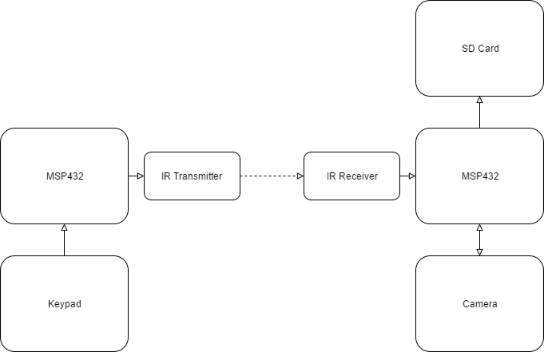

**Figure 1: Overall system block diagram**

3.)

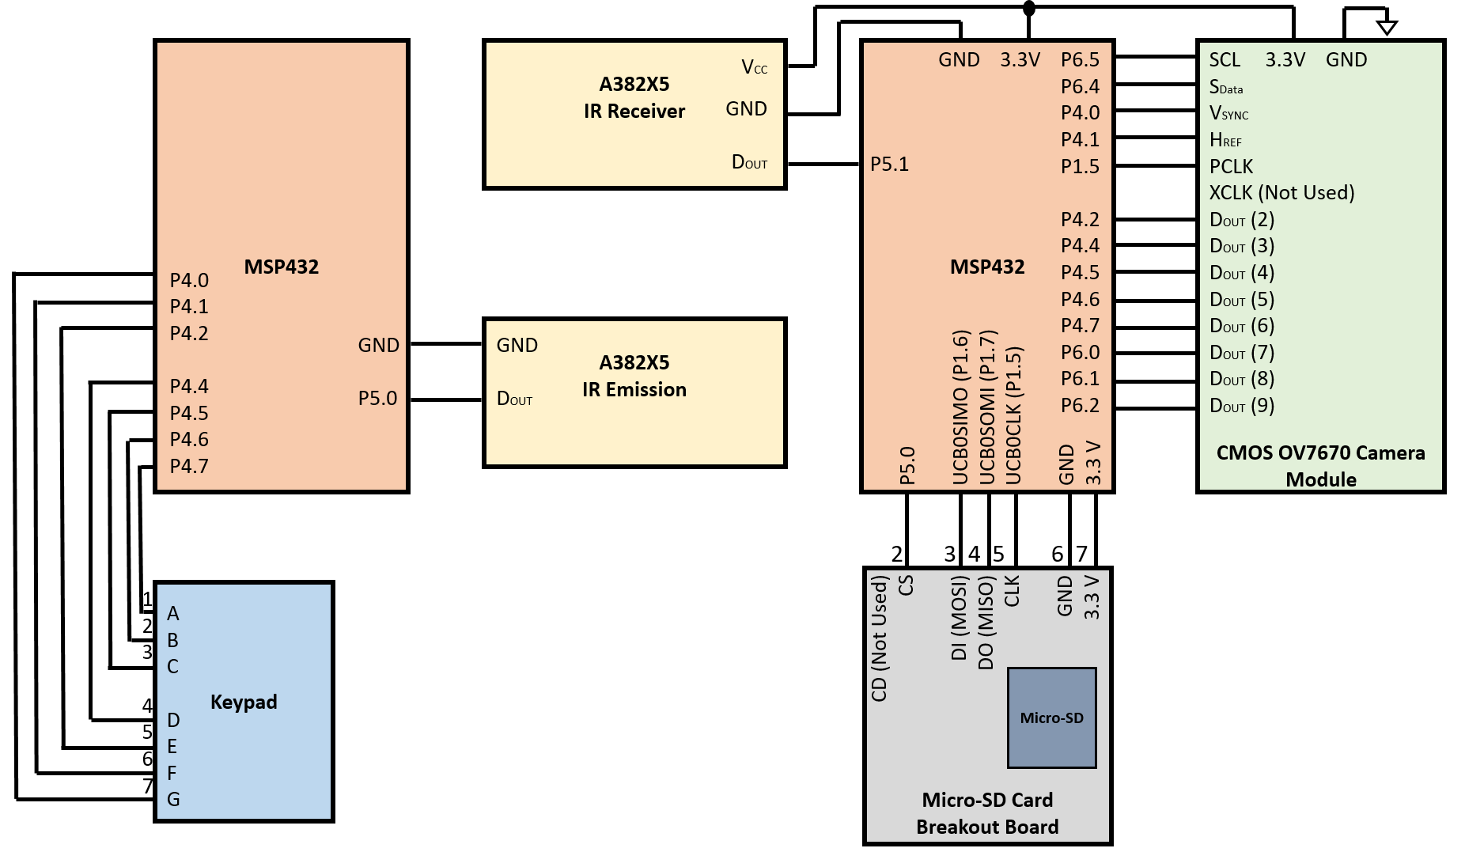

**Figure 3: Schematic Diagram**